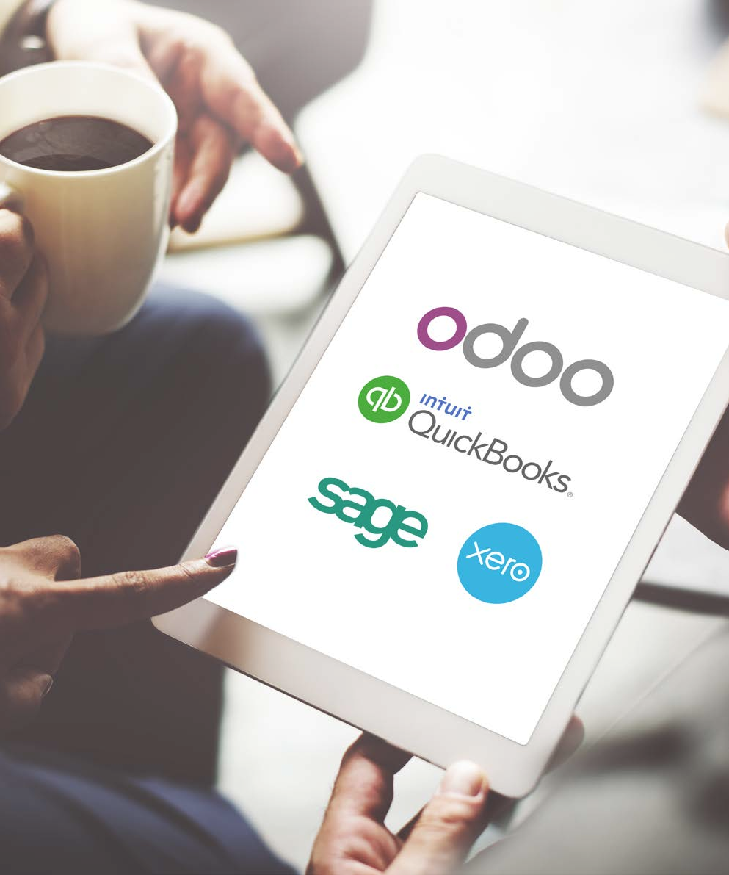

Accounting Comparison White Paper:

Odoo, Quickbooks, Sage & Xero

June 2016

# Introduction

2

### Introducing Accounting offers available today

Traditionally accounting has been treated as one of the dull and unexciting aspect of a business. Howev- er, as the business evolves the accounting department will become arguably one of the most important components in the success of that business. Accountants are perfectly positioned to be some of the most valuable informational resources in a company. They know the ins and outs of how the organization operates and are intimately acquainted with the organization’s current and projected financial position. It is critically important for the financial health of an organization to provide the accounting team with the tools they need in order to effectively monitor these factors.

There are many accounting software offers on the market capable of providing the features and report- ing functions accountants need, but where should the search for the best choice begin? Most growing businesses use a commercial management solution for their business operations. The ideal solution for these businesses would be to choose an accounting software that can be integrated with their current commercial solution. This will save a great deal of time and resources for the organization.

Accounting software is available either installed locally or through a cloud service provider. While both types of software have their own unique advantages, online offers are becoming increasingly popular choices amongst small and medium size businesses (SMBs) given the simplicity and low cost of implementation.

### Features Comparison

We decided to compare the biggest players on the market with Odoo, including Quickbooks, Sage, and Xero.

In order to offer a fair comparison of the most popular accounting solutions, we have compiled a table of the most important features an accounting software should offer. These are organized into 6 main categories: General Accounting, Accounts Receivable, Accounts Payable, Bank & Cash, Extras, and Reporting.

These categories encompass almost everything a company needs in order to manage its finances.We have also

included a comprehensive list of the pricing conditions and usability analysis for each solution in this comparison.

# Comparing Accounting Software Offers

3

## Odoo Online

Odoo is an open source software that is available in three versions, of which two are local and one is hosted in the cloud. More than 360 apps are available thanks to the multiple developments made by Odoo and its community. Some of these apps are officially validated by Odoo, whereas others are developed by the community and dedicated to specific versions for specific needs.



|  |  |
| --- | --- |
| YOUR BUSINESS ”  oo Accounting, Odoo Online. The of this software is the full integra- st of the Odoo ecosystem, so there enter data twice or develop third- ns. Odoo offers more than 30 apps, to the same database, which cover  business cases ranging from sales and CRM d manufacturing. | 2+  million users |
| 120+  countries |
| 730  partners | 1,500  developers |

“ GROW

version of Od unique feature tion with the re is no need to party integratio all connected many

to inventory an

Quickbooks

4

Quickbooks is an accounting software for small and medium businesses created in 1994 by the finan- cial software company Intuit. The software has since been split into two versions with industry-specific features added to broaden its appeal In 2014. Quickbooks counted more than 624,000 subscribers, making it one of the most widely used accounting software solutions in the US.

#### “ BUILT FOR YOUR SMALL BUSINESS. APPROVED BY ACCOUNTANTS ”



|  |  |
| --- | --- |
|  | +300  supported apps |
| created in  1994 |
| 50,000+  professional advisors | 1+  million subscribers |

Quickbooks is available in two versions: Enter- prise and Online. The Enterprise version is available online via additional hosting or locally. Quickbooks Online is available in 3 plans: Simple Start, Essential or Plus.

For this comparison, we will demonstrate Quick- books with its Online Essential product.

## Sage

5

Created in 1981, Sage was initially designed as a stand-alone accounting software. Since its inception, Sage has been significantly expanded to include a greater scope of both accounting and general business management features. Today, Sage offers a range of business management software products for business of all sizes. For this comparison, we have chosen Sage One Online Accounting, which we believe represents a good online accounting option for SMBs



|  |  |
| --- | --- |
|  | 100k  client organizations |
| 3,500  partners / re-sellers |
| 70+  countries worldwide | 3rd  largest ERP worldwide |

#### “ BOOKKEEPING ESSENTIALS FOR BUSINESS OWNERS. ”

Sage One has two editions: Sage One Accoun- tant Edition, with features intended to be used by freelance accountants and bookkeepers, and Sage Online Edition, designed for SMBs.

Sage One Online Accounting is restricted to finance and can be upgraded through a variety of adds-ons. For this comparison we chose to

compare the features of the Sage One Online

Accounting version.

## Xero

6

Xero was founded in 2006 in New Zealand by a business manager and accountant. They weren’t happy with the traditional desktop accounting software, so they decided to develop their own web-based solution.

Since then, Xero has grown to accommodate European and US markets as well as expanded it’s features and mobile functionality. In 2014, Xero was featured on the Forbes 100 Most Innovative Growth Companies.

#### “ BEAUTIFUL ACCOUNTING SOFTWARE ”



|  |  |
| --- | --- |
|  | 700k  subscribers |
| 16k  partners |
| 400+  adds-ons | 1,400  employees |

Xero is available only through their SaaS offer. Customers choose from one of three plans: Starter,

Standard, or

Premium. For this comparison we

chose the Standard Plan of Xero.

# Features Comparison

General Accounting

**Quickbooks Online Essentials**

**Odoo Accounting Online**

**Sage One Accounting Online**

**XERO**

Availability of an API









Google Spreadsheet Integration









Import: Excel or CSV









Export: Excel or CSV









Customer Portal

**3**







7

|  |  |  |  |  |  |
| --- | --- | --- | --- | --- | --- |
| **General Scope** | | | | | |
| Multi-Currency |  |  |  |  |  |
| Multi-Company Consolidation |  |  |  |  |
| Multi-User |  |  |  |  |
| Multiple Journals |  |  |  |  |
| Multi-Language Support |  |  |  |  |
| Supported Countries **1** | 1 | 40 | 10 | 4 |
| **Access Rights** | | | | | |
| Access Rights per Screen |  |  |  |  |  |
| Access Rights per Field |  |  **2** |  |  |
| Customizable Validation Steps |  |  |  |  |
| **Third Party-Integration** | | | | | |

1. Quickbooks is dedicated to the U.S. market. Xero is supported in 4 countries: Australia, New Zealand, US, and UK. Sage One Accounting Online is available in 15 countries: Australia, Botswana, Brazil, Canada, Germany, Ireland, Kenya, Malysia, Morocco, Namibia, Nigeria, South Africa, Switzerland, UK, US.
2. Available with some customization.
3. Add-on required for this feature.

### Accounts Receivable

##### Quickbooks Online Essentials

**Odoo Accounting Online**

**Sage One Accounting Online**

**XERO**

3

4

Available as an additional app.

Such as MRR, Churn, CAC ratio, CLTV, etc. It’s about recurring KPI, not custom KPI.

8

|  |  |  |  |  |  |
| --- | --- | --- | --- | --- | --- |
| **Customer Invoices** | | | | | |
| Proforma Invoices |  |  |  |  |  |
| Multiple Taxes per Line |  |  |  |  |
| Discounts |  |  |  |  |
| Pricelists |  |  |  |  |
| Multi-Step Payments Terms |  |  |  |  |
| Outstanding Payments Reconciliation |  |  |  |  |
| Emails Discussion as Attachment on Invoice |  |  |  |  |
| Configurable Email Templates |  |  |  |  |
| **Send Invoices** | | | | |  |
| Generate a PDF Invoice |  |  |  |  |  |
| Batch Send Invoices by Email |  |  |  |  |
| Post Invoices by Standard Mail |  |  |  |  |
| **Customer Statements** | | | | |  |
| Aged Receivable Balance |  |  |  |  |  |
| Per Customer Statements |  |  |  |  |
| Automated Follow-up Letters |  |  |  |  |
| Automated Follow-up Actions |  |  |  |  |
| Unpaid Fees and Penalties |  |  |  |  |
| Third-Party Debts Recovery |  |  |  |  |
| **Online Payments** | | | | |  |
| Credit Cards |  **1** |  |  **2** |  |  |
| PayPal |  **3** |  |  |  |
| **Recurring Revenues** | | | | |  |
| Automated Recurring Invoices |  |  |  |  |  |
| Contrats / Subscriptions Management |  |  |  |  |
| Recurring Business KPI **4** |  |  |  |  |
| Alerts for Contract Renewal |  |  |  |  |
| **Miscellaneous** | | | | |  |
| Automated COGS Entries  Automated Deferred Revenues |    |    |    |    |  |

1. Included for an additional fee.
2. Sage Payment Solutions add-on necessary.

Accounts Payable

**Quickbooks Online Essentials**

**Odoo Accounting Online**

**Sage One Accounting Online**

**XERO**

9

|  |  |  |  |  |  |
| --- | --- | --- | --- | --- | --- |
| **Vendor Bills** | | | | | |
| Billing Control  (Purchase Orders / Receptions) |  |  |  |  **1** |  |
| Multiple Taxes per Line |  |  |  |  **2** |
| Purchase Agreements |  |  |  |  |
| Multi-Step Payment Terms |  |  |  |  |
| **Vendor Payments** | | | | | |
| Aged Payable Report |  |  |  |  |  |
| Print Checks |  |  |  |  |
| Automate Wire Transfers  (SEPA) |  |  |  |  |
| ACH Transfers |  **3** |  |  |  **4** |
| **Expenses** | | | | | |
| Employee Expenses Report |  **5** |  |  |  |  |
| Expenses Validation Flow |  |  |  |  |
| **Miscellaneous** | | | | | |
| Assets Management |  |  |  |  |  |

1. Available with add-on.
2. Xero supports compound taxes. Possibility to manage multiple taxes with a compound tax.
3. Available with Quickbooks Payments.
4. Available with add-on.
5. Available with QuickBooks Online Payroll.

### Bank & Cash

##### Quickbooks Online Essentials

**Odoo Accounting Online**

**Sage One Accounting Online**

**XERO**

|  |  |  |  |  |  |
| --- | --- | --- | --- | --- | --- |
| **Bank Statements** | | | | | |
| Bank Interfaces |  |  |  |  |  |
| Import Statements: QIF |  |  |  |  |
| Import Statements: OFX |  |  |  |  |
| Import Statements: CSV |  |  |  |  |
| Import Statements: Coda |  |  |  |  |
| Import Statements: Camt.053 |  |  |  |  |
| Deposit Tickets |  |  |  |  |
| **Miscellaneous** | | | | | |

Bank Reconciliation Reports

Automated Currencies Rate Update

   

   

1. Available with add-on.
2. Available with Quickbooks Online PLUS.

10

|  |  |  |  |  |  |
| --- | --- | --- | --- | --- | --- |
| **Analytic Accounting / Grouping** | | | | | |
| Analytic / Cost Accounting |  |  |  |  |  |
| Multi-Level Analytic Accounting |  |  |  |  |
| Multiple Plans |  |  |  |  |
| Optional Tags per Entry |  |  |  |  |
| **Budgets** | | | | | |
| General Budgets |  |  |  |  |  |
| Analytic Budgets |  |  |  | □ |
| **Payroll** | | | | | |
| Payroll |  **1** |  |  **2** |  |  |
| **Valuation** | | | | | |

1. Quickbooks offers import of payroll tax tables for an additional fee.

Extras

**Quickbooks Online Essentials**

**Odoo Accounting Online**

**Sage One Accounting Online**

**XERO**

Standard Price Average Price FIFO & LIFO

Perpetual Inventory Valuation





**4**

**6**

















**3**



**5**



1. Sage One Payroll integration available.
2. Available with add-on.
3. Available with Quickbooks Online PLUS.

Reporting

**Quickbooks Online Essentials**

**Odoo Accounting Online**

**Sage One Accounting Online**

**XERO**

11

|  |  |  |  |  |  |
| --- | --- | --- | --- | --- | --- |
| **Legal Statements** |  | | | | |
| Profit & Loss |  |  |  |  |  |
| Balance Sheet |  |  |  |  |
| Cashflow statement |  |  |  |  |
| General Ledger |  |  |  |  |
| Tax Reports |  |  |  |  |
| Tax Audit Report |  |  |  |  |
| **Reports** |  | | | | |
| Pivot Table on Multiple Dimensions |  |  |  |  |  |
| Customizable Reports |  |  |  |  |  |
| Customizable Dashboards |  |  |  |  |  |
| Annotate Reports |  |  |  |  |  |
| Customizable KPI's |  |  |  |  |  |
| Predefined Executive  Summary |  |  |  |  |  |
| Perpetual Fiscal Year Closing |  |  |  |  |  |

# User Interface

12

When it comes to efficiency and end-user satisfaction, fine-tuned usability is one of the most important factors in any software platform. This is especially true of accounting software, as the end user might spend the majority of their time working within the software. In order to provide functionality, speed, and convenience to an accounting team, a software solution must maintain a balance between ease of use and a robust set of features. The user interface supports the overall product design in deciphering human factors such as preferences, habits, and learned skills in order to effectively serve the intended purpose of the software as it relates to the businesses that utilize it. A strong functional design is critical in providing a positive user experience and maximizing user efficiency.

Usability is qualitatively measured as a software’s ability to anticipate what a user might need to do. This includes ensuring that all of the elements in the interface are easy to access, understand, and use. Well designed software establishes familiarity by maintaining a consistent interface and predictable interac- tions throughout so users feel comfortable with the system, allowing them to complete their desired tasks quickly. It will help users perform actions quickly as well as become more efficient in their day to day tasks. Best practices also suggest having a simple interface with consistency (common elements) and a page layout based on hierarchical importance and flow.

The next section includes screenshots of the dashboard and bank reconciliation screens of each software to help you compare the user interface of each software.

## Dashboard - Odoo

13

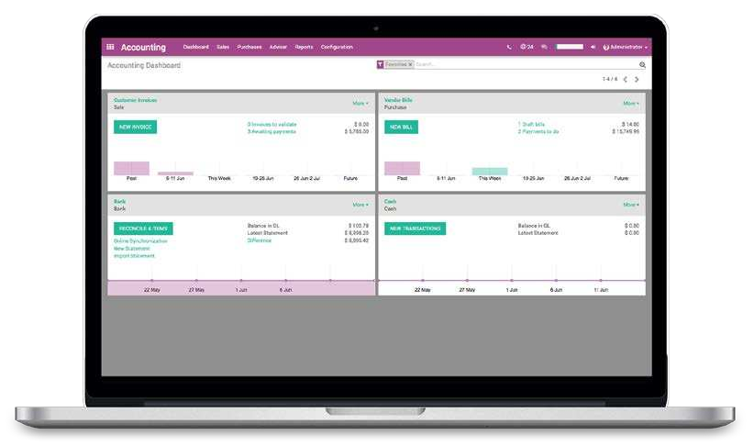

Bank Reconciliation - Odoo

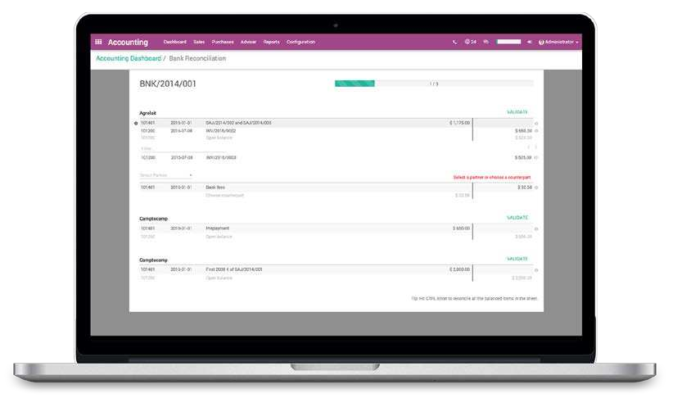

Dashboard - Quickbooks

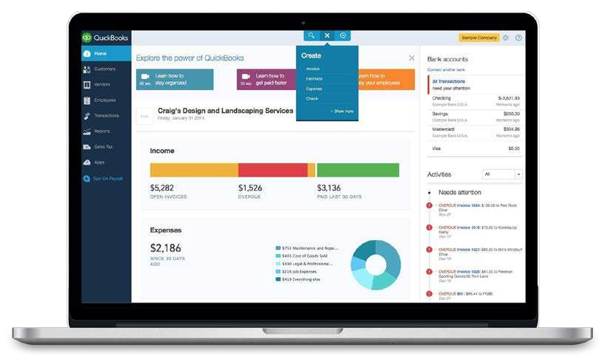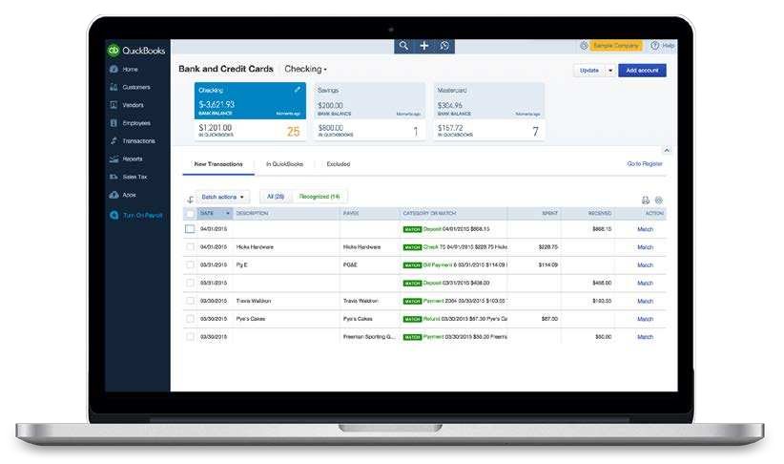

Bank Reconciliation - Quickbooks

14

## Dashboard - Sage

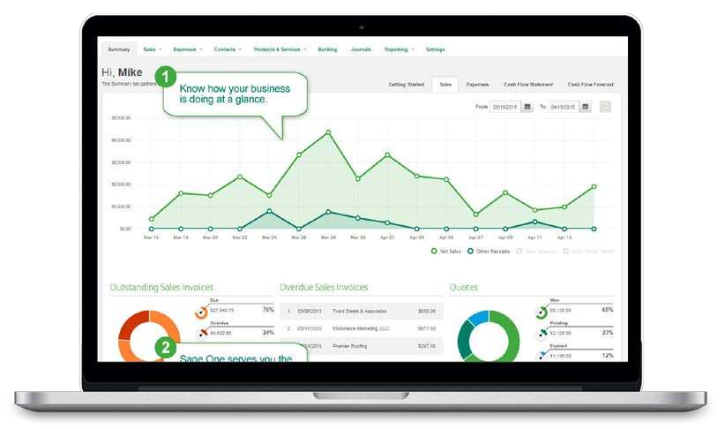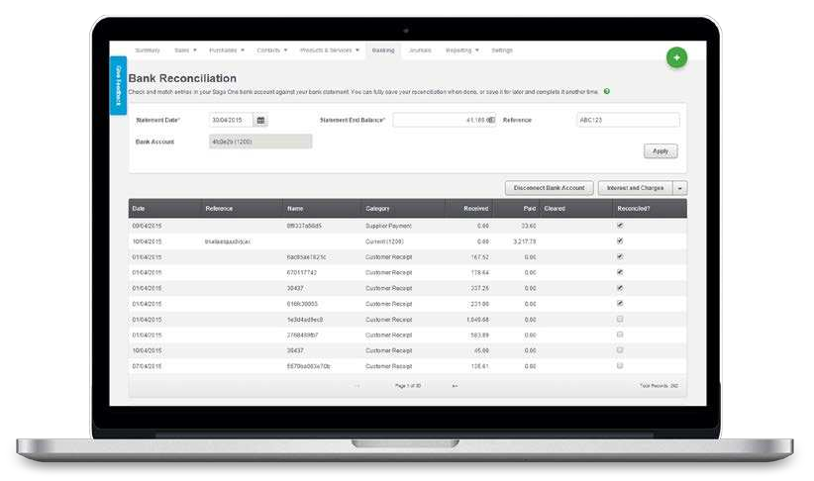

Bank Reconciliation - Sage

15

## Dashboard - Xero

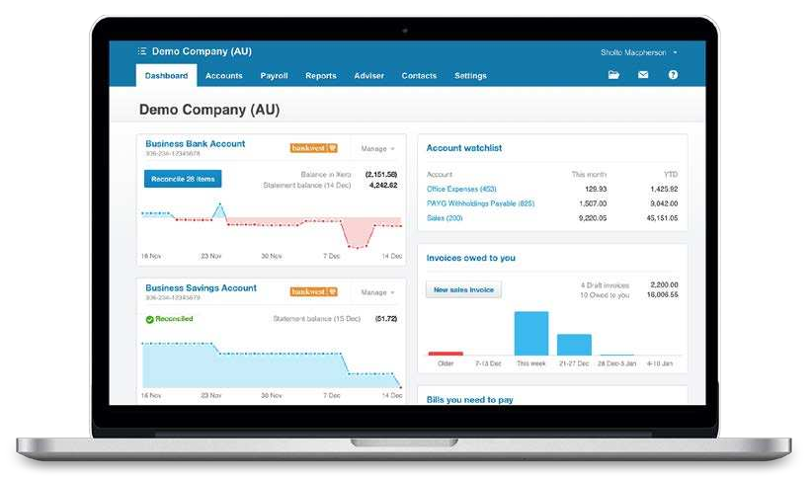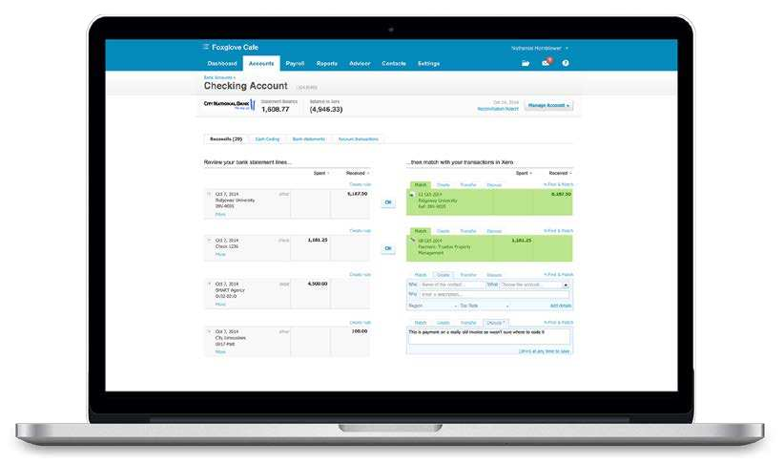

Bank Reconciliation - Xero

16



Navigation and Search Data Entry Reconciliation Tool Mobile App

Reports Flexibility

**Subjective Ratings**

Usability

**Quickbooks Online Essentials**

**Odoo Accounting Online**

**Sage One Accounting Online**

**XERO**

**UI**

Full Web Interface









Mobile App









Android App









iPhone App









**Market Place**

App Store / Add-ons









    

    

    

    

    

    

    

    

    

    

    

    

    

     **1**

    

    

    

    

    

    

1 Odoo currently optimizes for mobile automatically within your browser. Dedicated mobile app available October 2016.

17

# Pricing & Conditions

18

|  |  |  |  |  |  |
| --- | --- | --- | --- | --- | --- |
| Pricing & Conditions | **Quickbooks Online Essentials** | **Odoo Accounting Online** | **Sage One Accounting Online** | **XERO** |  |
| **MONTHLY PRICING** | $27 | Free **1** | $10 | $30 **2** |  |
| Number of Users | 3  Monthly 30 Days       | Unlimited n/a         **3** | Unlimited Monthly 30 Days       **4** | Unlimited 6 Months         |  |
| Contract Duration |
| Free Trial |
| Free Updates |
| Hosting & Maintenance |
| Support |
|  |  | | | |  |

1. Odoo Accounting is free for unlimitied users, as long as you use solely the Accounting app; when other apps are added (ex. Subscription, Sales, eCommerce, Inventory), the cost is $25/user with apps priced individually (support is included).
2. Xero costs $70 per month if you need multiple currencies.
3. If you use Odoo Accounting in the free offer, support is not included. If you have other apps added (ex. Subscription, Sales, eCommerce, Inventory), general support is included at no charge in your monthly contract.
4. Only forum and tutorials.

|  |  |  |  |  |  |
| --- | --- | --- | --- | --- | --- |
| User Satisfaction | **Quickbooks Online Essentials** | **Odoo Accounting Online** | **Sage One Accounting Online** | **XERO** |  |
| Ratings on g2Crowd | 2/5 | 4/5 | n/a | 4.3/5 |  |
| Ratings on GetApp | 4/5 | 5/5 | 5/5 | 4.5/5 |
| Ratings on Capterra | 3.5/5 | 5/5 | 4.5/5 | 3.5/5 |
| Brand Exposure |      |      |      |      |
|  |  | | | |  |

please report it to [feedback@mail.odoo.com](mailto:feedback@mail.odoo.com) and we will update this document. Our goal is to have a continuously updated compar-

ison of the main competitors to be as accurate as possible.

19

# Conclusions

The selection of a software solution is a process which, if undertaken with scrutiny and a willingness to

obtain as much information as possible, can result in a huge increase in efficiency amongst your team.

No single factor (cost, number of features, UI) is the most important, but rather a balance of many inter- dependent factors. Which factors are really important for your business? Is your planning focused around budget? Integration with third-party apps? Are you looking for software that simplifies your accounting or do you have an accounting expert on staff that needs a powerful solution? Proper balance between all these elements will lead to optimal end results when selecting the accounting software that fits your unique business needs.

In order to select the best accounting software for your needs, it is also vital to weigh the desired benefits against the management team’s constraints while also considering the accounting team’s day to day oper- ational needs. The most fundamental goals for any decision maker are to grow the business and support the teams which makes the success of your organization possible. As collaboration is the key to success with any team, it is beneficial to choose a simple and user-friendly solution which will help your colleagues to work quickly and effectively while avoiding the need for expensive and time consuming training sessions.

So whether you are a small startup comparing accounting solutions for the first time or a large enterprise thinking about changing your current software, the information in this document will help you compare the most important aspects of each accounting solution to help you find the software that best works for you.

This whitepaper was compiled by Odoo SA. We did our best to make it objective and fair. If you find a mistake or a missing feature,